Virtual Memory

In addition to using physical RAM to store programs and working data, Windows 7 creates a hidden file on your primary hard disk and uses that file to swap pages of data out of physical memory when necessary.

This page file is also sometimes referred to as a paging file. (In fact, different dialog boxes throughout Windows 7 use different terms to refer to this file.) In the interest of convenience and consistency, we use the term page file throughout this book.

In a default Windows 7 installation, Windows creates the page file in the root folder on the same drive that holds the Windows system files. The size of the page file is determined by the amount of RAM in your system. Prior to Windows 7 the default paging file size was determined differently on different versions of Windows (usually between 1.5 and 3 times RAM). In Windows 7 the default size is equal to the amount of memory installed in the machine.

You can see the page file in a Windows Explorer window if you configure Windows to show hidden and system files. You can do this as follows:

Windows 7 hides certain files so that they are not able to be seen when you exploring the files on your computer. The files it hides are typically Windows 7 System files that if tampered with could cause problems with the proper operation of the computer. It is possible, though, for a user or piece of software to set make a file hidden by enabling the hidden attribute in a particular file or folder's properties. Due to this it can be beneficial at times to be able to see any hidden files that may be on your computer. This tutorial will explain how to show all hidden files in Windows 7.
To enable the viewing of hidden and protected system files in Windows 7 follow these steps:

- Open Windows Explorer.
- Click on Tools -> Folder Options -> View.
- Click on the “Show hidden files and folders” option.
- Under the Hidden files and folders section select the radio button labeled Show hidden files, folders, and drives.
- Remove the checkmark from the checkbox labeled Hide extensions for known file types.
- Remove the checkmark from the checkbox labeled Hide protected operating system files (Recommended).
- Press the Apply button and then the OK button.

.
Now look for Pagefile.sys in the root of your system drive (C:)

An option in the System Control Panel lets you see your current page file settings and adjust them as needed. You can change the size of the page file, move it to another drive, or split it over several physical drives to improve performance.

To view and change page file settings, follow these steps:

- Open the System Control Panel. Click on Advanced system settings.
- Click on Advanced tab.
- In the Performance section click on Settings.
- Again click on Advanced > click on Change in the Virtual Memory section.

Note the system is automatically managing the size of the swap file. Unclick the box at the top if you want to manage the file yourself.

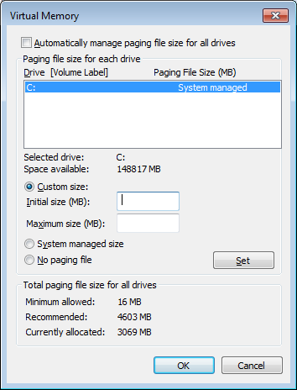

Exercise
For the C: drive,
What is the current size of the page file? 8061MB

Tip: Play it safe with your page file

On systems with 512 MB or more of physical memory, the large initial size of the page file can consume excessive amounts of disk space. On a system with 1 GB of RAM, for instance, the starting page file size is 1GB, and under normal circumstances it’s likely that this file will never be used. The best strategy for page-file management in this configuration is to set Initial Size (MB) to be relatively small—say, 512 MB—while setting a large Maximum Size (MB) so that Windows can increase the page file size if necessary.

If disk space is really tight, set the initial page file size to its minimum of 2 MB and set the maximum size to a value that is at least as large as the amount of installed memory. Use your computer normally for a few weeks and allow Windows to create a page file of the proper size. Use Task Manager to monitor the size of the page file and make certain that it’s below the maximum size you specified.

Using Disk Defragmenter

On a freshly formatted disk, files load fairly quickly, but over time, performance can degrade because of disk fragmentation. To understand how fragmentation works, it helps to understand the basic structure of a hard disk. The process of formatting a disk divides it into sectors, each of which contains space for 512 bytes of data. The file system combines groups of sectors into clusters, which are the smallest units of space available for holding a single file or part of a file.
On a 10-GB NTFS drive, the cluster size is 4 KB. Thus, when you save a 10-MB movie clip on a drive that size, Windows divides the file into approximately 2,560 pieces (NTFS). MP3 file of a single song will consist of about 1,000 clusters.
When you save this file for the first time on a freshly formatted hard disk, Windows writes it in contiguous clusters. Because all the clusters that hold individual pieces of the file are physically adjacent to one another, the mechanical components of the hard disk can work very efficiently, scooping up data in one smooth operation. As a bonus, the Windows disk cache is able to anticipate the need for data and fetch nearby clusters that are likely to contain other parts of the file, which can then be retrieved from the fast cache rather than from the relatively slow disk.
Unfortunately, hard disks don’t stay neatly organized for long. When you add data to an existing file, the file system has to allocate more clusters for storage, typically in a different physical location on the disk. As you delete files, you create gaps in the once-tidy arrangement of contiguously stored files. As you save new files, especially large ones, the file system uses all these bits of free space, scattering the new files over the hard disk in many noncontiguous pieces. The resulting inefficiency in storage is called fragmentation; each time you open or save a file on a badly fragmented disk, disk performance suffers, sometimes dramatically, because the disk heads have to spend extra time moving from cluster to cluster before they can begin reading or writing data.

Using Disk Defragmenter
The Disk Defragmenter utility improves performance by physically rearranging files so that they’re stored in contiguous clusters. In addition to consolidating files and folders, the utility also consolidates free space, making it less likely that new files will be fragmented when you save them.

To open the graphical Disk Defragmenter console, use any of the following techniques:
● Click Start and type “Disk Defragmenter” into the Search text box

● Click Start, click Computer, right-click any drive icon and choose Properties from
the shortcut menu. Then click the Tools tab and click Defragment Now.

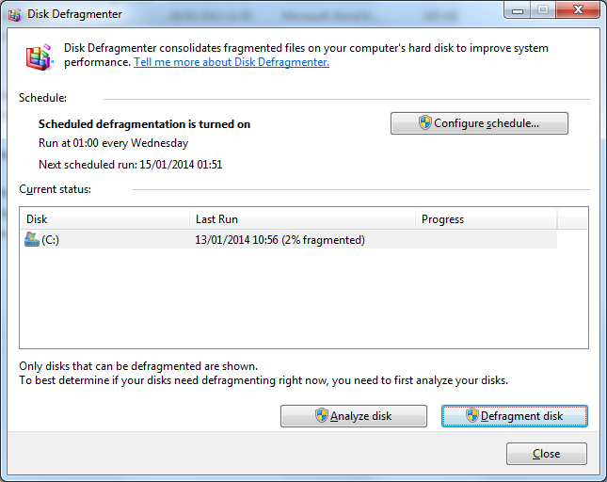

In Disk Defragmenter’s upper pane, select the disk you want to operate on. To find out how seriously fragmented the disk is currently, click Analyze. Disk Defragmenter presents a graphical fragmentation display and makes a recommendation about whether your disk needs to be defragmented. On Windows XP, for more details about the condition of your disk, click View Report. Disk Defragmenter responds with statistics about the overall level of fragmentation and lists the most highly fragmented files, as shown below.

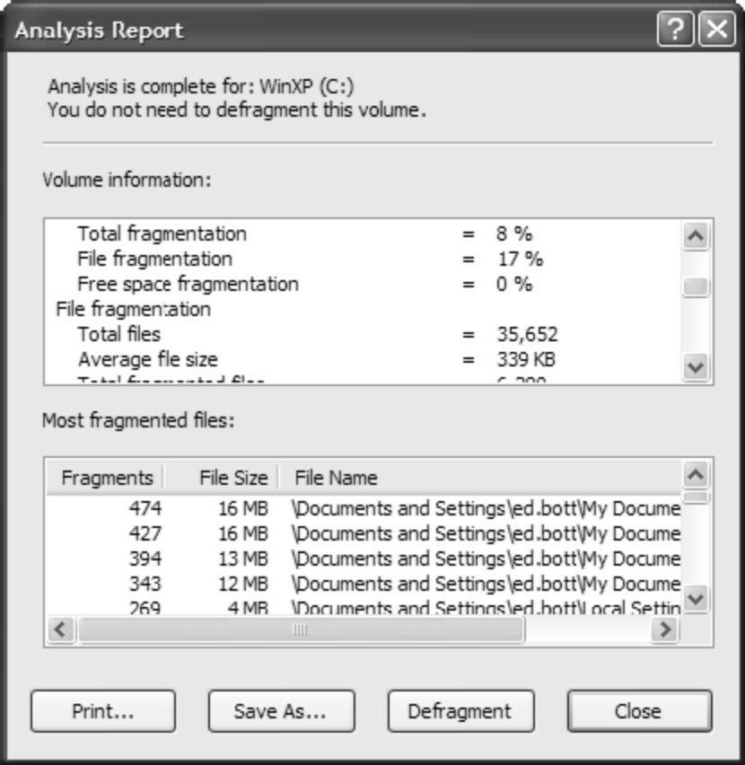

This report format lets you see overall fragmentation percentages and identify files that are most widely scattered.

Exercise: Run Disk Defragmenter. Choose Analyse, then View Report. What is the most fragmented file on the C drive?_______________

To begin the defragmentation process, click the Defragment button. Do not do this now as it takes some time to complete this process.

